How to Randy
A guide to librarian dominance by glmnola

Notes from the Crazed:

I’ve been on PowerPets for a while now, and the Power Dome has drawn my attention more than other part of the site. This guide is an aim to reveal the strategy to defeating Randy and obtaining the Emerald Stone. It’s no easy task, but it is far from impossible. I did it a few days after the Emerald Stone had been released, with much less armor and strength than my pet currently has, so there’s hope for you too!

Disclaimer:

I cannot promise you’ll be a Randy defeating monster after reading this guide, but I can promise you’ll never fear the library again.

Pet used:

To defeat the scholar Randy, I used my pet Glamradriel. She’s my beefiest pet, but don’t tell her I said that. Her stats were as follows:

Leather: 400/400
Steel: 200/200
Titanium: 150/150
Diamond: 103/103

Strength: 1961/1961

Tools of Destruction:

I decided to use all buyable weapons to defeat Randy so that you don’t think you need PT weapons to take him down. When I defeated Randy for the Emerald Stone, I used PT weapons. However, this is not mandatory, as I will show you in this guide. My line up included:

Cupids Shield
Radioactive Claw
Baru Blade
Moon Hook Blade
Blizzard Shield
Slime Powder Vial 1000mm (x2)
Multi Repair Patch 1000

Cupids Shield
Leather | 3
Steel | 4
Titanium | 6
Diamond | 5
Range | none


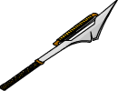


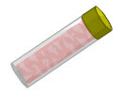
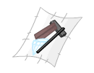
Radioactive Claw
Leather | 5
Steel | 7
Titanium | 5
Diamond | 6
Range | Medium
Baru Blade
Leather | 7
Steel | 5
Titanium | 6
Diamond | 0
Range | Short
Moon Hook Blade
Leather | 6
Steel | 1
Titanium | 6
Diamond | 6
Range | Short
Blizzard Shield
Leather | 4
Steel | 6
Titanium | 6
Diamond | 6
Range | None
Slime Powder Vial 1000mm
restores 1000 strength
Multi Repair Patch 1000
Leather | 1000
Steel | 1000
Titanium | 1000
Diamond | 1000
Range | none
restores 1000 of each armor
Before you try and use a shield to take Randy’s head off, shields can only block damage. Damage is dealt and blocked based on how much strength is used. Strength provides the power to use the item, and then depending upon whether it is a shield or an attack weapon, damage is either dealt or blocked.

It should also be noted that I choose to not use duplicate items. This is a personal preference because it adds a slight challenge when I can’t just rely on copies of a single great weapon, I have to use multiple weapons. It’s not a big deal, it just adds some extra difficulty. It would be better to use 2 Blizzard shields instead of a Cupids Shield, but that’s less challenging.

I’m not going to go into detail about upgraded weapons in this guide. Obviously, weapons that deal more damage than the ones I use, or block more damage than the ones I use, are great upgrades and better alternatives. I’m using the cheapest, most effective weapons to prove a point, not to defeat Randy easily. I encourage you to use stronger weapons than those that I use, but we can’t all be millionaires, and I acknowledge that. These are the cheapest, best weapons I could find. They each cost under 70,000pbs and are capable of beating Randy.

Randy a.k.a. Destroyer of Small Galaxies:

Randy eats small pets for breakfast, just after he reads encyclopedias for an hour. His stats are as follows:

Leather: 1500/1500
Steel: 1500/1500
Titanium: 1500/1500
Diamond: 1500/1500

Strength: 3500/3500

Tools of Instruction:

Randy has a few nasty weapons in his arsenal, but for the most part, his weapons are moderately wimpy. His weapon list includes:

Tennis Ball Cannon – long range
Rainbow Sceptre – medium range
Axe of Affliction – medium range
Ice and Fire Trinity Shield - shield
Multi Repair Patch 1000 - repair
Force of Shadow – medium range
Radioactive Claw – medium range

Notice that Randy lacks a short ranged weapon and a slime vial. This means that he is susceptible to short ranged attacks and that he can be drained. This is what we will be taking advantage of.

Phase 1 - Bob and Weave:

This is arguably the most important part of the fight. We begin the fight facing Randy, several blocks apart.
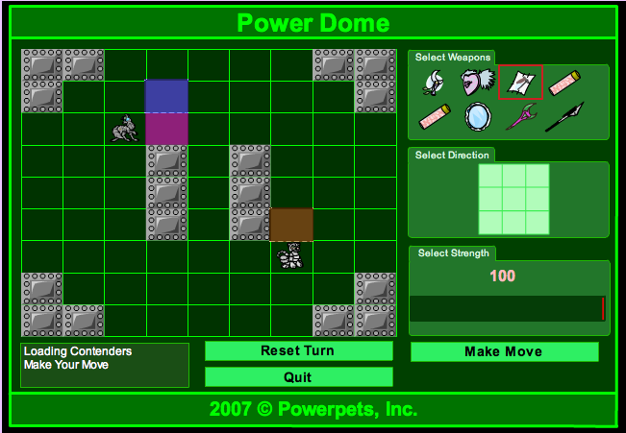
Notice that if we move into the magenta square and Randy moves into the orange (close enough to orange) square, we’ll be within range of his Tennis Ball Cannon, which is long range. Therefore, we instead move into the blue square, safe from Randy and still advancing towards him. Since we aren’t within range, we’ll use 0 strength, no weapons, and aim in any direction. Remember, we’re reserving strength.

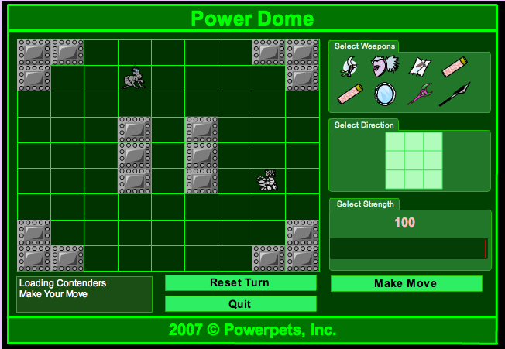

In our case, Randy moves northeast and uses his Force of Shadow. We take 0 damage, use 3 strength, while Randy uses 18 strength and takes 0 damage. Now we’re in range for a long ranged attack. If we move east and Randy moves north, we’ll be within long range. If we move southeast, and Randy moves northwest, we’ll be within medium range, which is what Randy is exceptionally good at. We want to avoid medium range at all costs, and only be within medium range for the least amount of time possible and for at most two turns. So, to avoid medium range, we’ll move east, and since we could possibly be within range of Randy’s long ranged attack, we’ll use both of our shields at 138 strength. Keep in mind that the arena adds 5 strength to whatever strength you select, so in actuality we’re using 143 strength. With a Cupids Shield and Blizzard Shield at 143 strength, we’ll block all of Randy’s damage (if you have 2 Blizzard Shields, use both of them and 120 strength to block all damage with a total 125 strength used).

Phase 2 – Duck and Cover
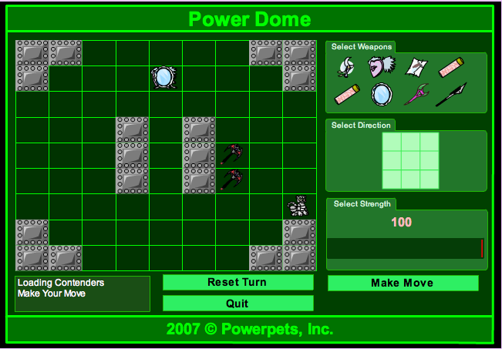
Randy decides to move southeast and use his Axe of Affliction at 17 strength. In this case, we just wasted 143 strength, but we had to so that we wouldn’t get beaten up. Don’t worry, we have 2000mm of slime in reserve. You did bring your slime vials, right? This time, we’re going to move southeast. Again, if Randy moves northwest or north, we’ll be within range of his Tennis Ball Cannon. So again, we’ll move southeast, dual block with both of our shields and 138 strength and continue pursuing Randy to get within close range.

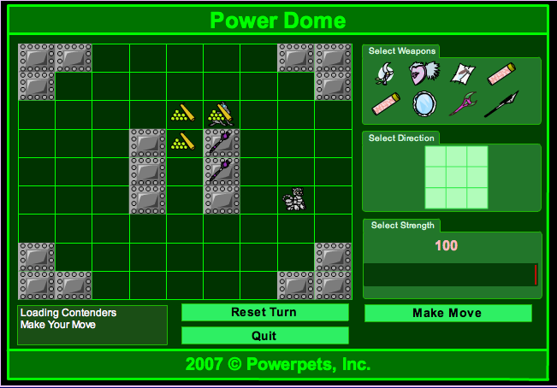
Thank goodness for math! As you can see, Randy moved northwest and used his Tennis Ball Cannon and Force of Shadow at 200 strength! Luckily, we blocked ALL the damage with both of our shields and 143 strength. Now for the stats update:

Glamradriel:
Leather: 450/450
Steel: 200/200
Titanium: 150/150
Diamond: 103/103
Strength: 1672/1961

Randy:
Leather: 1500/1500
Steel: 1500/1500
Titanium: 1500/1500
Diamond: 1500/1500
Strength: 3265/3500

We’re not doing too badly on strength. Randy still has over 3000, but we’re not too worried about that, as we didn’t plan on defeating him before we get within short range. Now we’re ready to keep moving forward. Because we’re so close to him now, it is important for us to play VERY defensively. This is the most important part of the entire match: closing in. Once we’re within short range, we’re golden and it’s just a slow steady beat down to victory. We don’t want to risk it all here though and get stuck in medium range to suffer Randy’s big weapons. Remember, we want to be at medium range for as little amount of time as possible. We’ll move southeast and this time we’re going to use 200 strength. We do NOT want to be hit by Randy’s big nukes, so we don’t risk it. Remember, we have plenty of slime vials for back up if we need it. Let’s analyze where Randy can move, and where we want him to move. If he moves north, we’ll be within short range and safe from harm. The same applies for if he moves northwest. If he moves west, east, northeast or east, we’ll be within medium range and in range for a beat down. This is what we DON’T want. If he moves south in any direction, we’ll be back in long range, but because we’re shielding, we won’t take damage anyway from his Tennis Ball Cannon. So, here we go. We’ll move southeast, use both shields, and 200 strength.
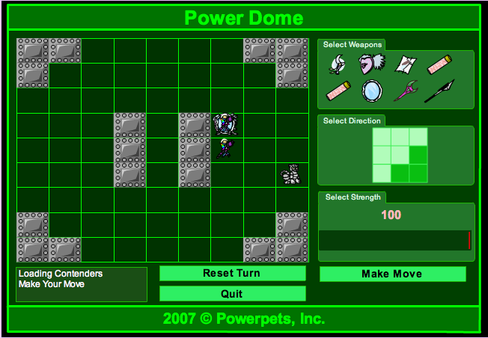
Oh man! Is there a book on first-aid anywhere? Direct hit from Randy. He used a Force of Shadow and a Rainbow Sceptre at 200 range. The damage went a little something like this:

Leather: 244
Steel: 183
Titanium: 0
Diamond: 427

Leaving Glamradriel with:

Leather: 156
Steel: 17
Titanium: 150
Diamond: 0

Yikes! This is why we don’t want to sit in medium range with Randy. Now we’re in a little predicament. We’re low on our armor, and we still aren’t within short range of Randy. You can take 2 approaches at this point. We still want to pursue Randy, but we don’t want to get knocked out. Our two options are this, we can either risk getting hit with dual medium ranged weapons again and dual block, or we can use our Multi Repair Patch 1000 and a shield and hope we don’t get destroyed. Be sure to use a Multi Repair Patch 1000. Even though I don’t have 1000 of each armor, it acts as a shield, giving Randy 1000 armor to try and rip through before he damages me. I’m a little more adventurous, so I decided to take my chances and dual shield again with 200 strength. If Randy hits me and I survive, or he moves out to medium range again, I’ll have to repair and use my slime vial on the next turn to try and stay alive. As for where Randy can move, if he moves north, northeast, or west, we’ll be within short range and safe. If Randy moves southwest or west however, we’re toast. I like to play the odds though, and 3:2 seems like a fair bet, so I use dual shields at 200 strength and move southeast. I’d like to note here, Glamradriel is a fairly well armored pet. If you take a big hit and find yourself in my shoes but with less armor, I would suggest using your repair patch on this turn and not saving it.
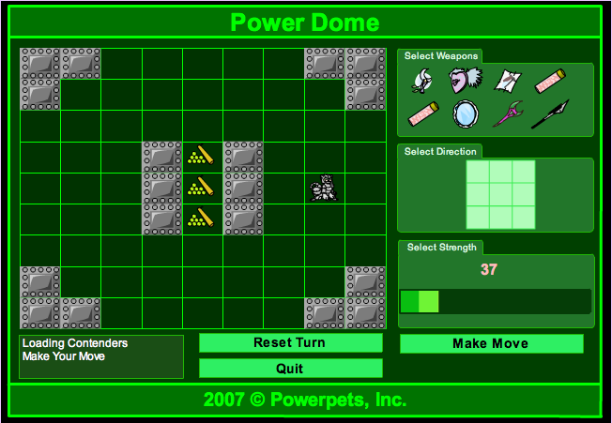
This is bad. As you can see, Randy moved RIGHT on top of me. We didn’t take any damage, but now we’re unable to shadow him on our next move. We want to stay in short range, but since we’re both on the same square, it’s up to luck at this point that we don’t get stuck in medium range again. I’m going to take this time to repair up, using my repair patch and shield at 200 strength. Even though we’re on top of each other, my next move still plays a very important role in the match. I want to move either north or south, as this will maximize my chances to stay within short range (hopefully). I’ll use the repair patch I saved from last turn and my Blizzard Shield at 200 strength, moving north.
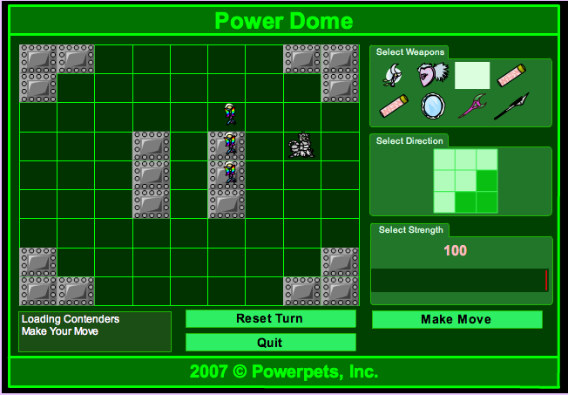
Wow, let’s hope you have better luck with this than I do. As you can see, Randy and I move to the same square AGAIN. I used my repair patch though, and now am at full armor again. This time I’ll use dual shields at 200 strength and try north again. Let’s hope we’re lucky.
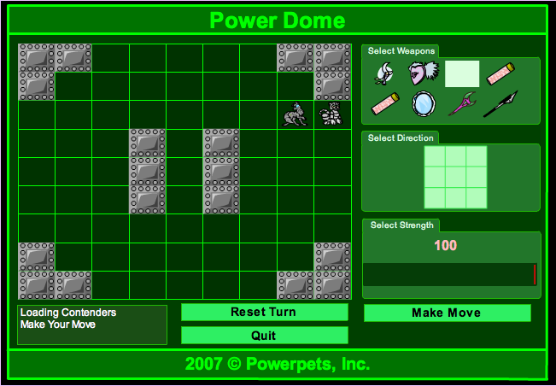
Perfect! Randy moved northeast and we moved north. Now Randy is within short range and can no longer hit us! This is where the slime vials come in handy. I’m down to 872 strength at this point and need to use a Slime Powder Vial 1000mm to restore some strength. Randy is at 2826 strength at this point, but we’re not worried because we’re within short range. For our moves this turn, we’ll move to the square Randy is standing on, east of us. We want to conserve our strength, so we’ll use 0 strength, a Slime Powder Vial 1000mm, and our Moon Hook Blade. The term I’m going to use for moving on the square Randy is on is called “shadowing”. Shadowing is moving to the square that your opponent is currently occupying, thus staying within short range the entire time. This is effective against opponents that lack short ranged weapons (such as Randy) because they can’t hit you! It’s all down hill from here.

Phase 3 – Stealing Randy’s Wallet

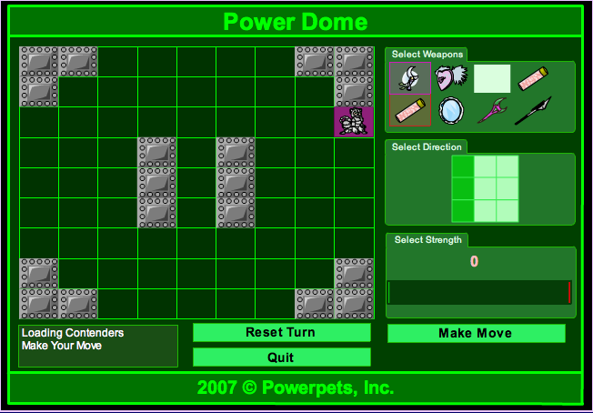 I haven’t made my move just yet, but notice that I’m using 0 strength, a Moon Hook Blade, and a Slime Powder Vial 1000mm. More importantly, look where I am intending to move. I want to move directly on top of Randy, thus shadowing him. He can’t stay in the same square, so he’ll have to move one square, which will keep him within short range. Also, take note of the direction I’m aiming my weapon. I know that I didn’t use any strength, but note where exactly I am aiming. Aiming your weapons is mostly luck from here on out. I want Randy to stay on the outside walls, away from the middle of the dome because it’s easier to aim when he has a wall behind him. Randy can move in one of four squares. Since I don’t want him to move away from the wall, that’s precisely where I aim. If he moves where I don’t want him to, he’ll have to pay the price! Also, I’m aiming at 3 of the 4 squares he can move to. That’s a 75% chance that he’ll be hit with my weapons! Though I’m not using much strength here, later on this will play a big role. Let’s see what Randy decides to do.
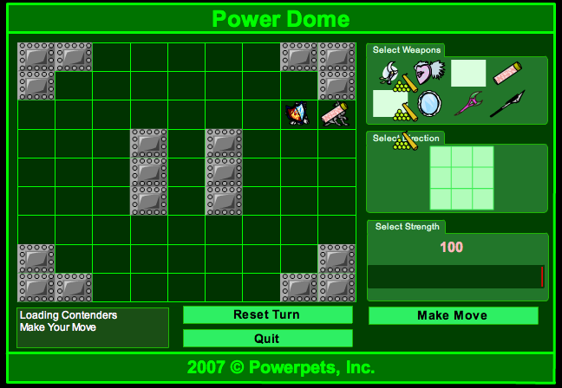
Great minds think alike I suppose. Randy moved right where I had been the turn before. Notice that I stayed within short range. This is called shadowing. I like to refer to it as trying to steal Randy’s wallet. Keep moving to the square he’s on. Maybe he left behind a retired book or something! At this point, Randy is down to about 2600 strength. All that is left now is to continue shadowing him (get that wallet!) until he is out of strength. Again, I’ll move to the square he’s on, use both of my short ranged weapons, and 0 strength as he still has a shield and I don’t want him to block any of my strengthy attacks.
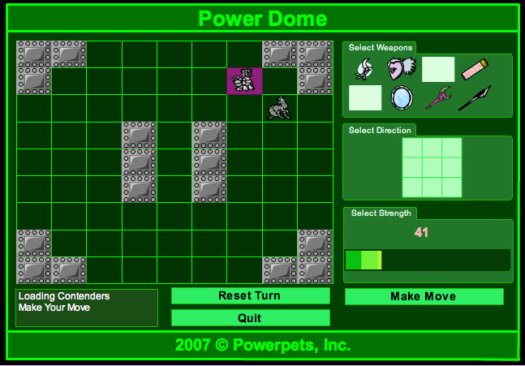
Randy moves to the northwest while I take the square he was just on. I’ll keep shadowing him and using 0 strength until he’s dry (out of strength). You may want to heat up some food or grab a drink at this point. It takes a while for him to run out of strength. Now I’ll move to where he is (notice where I’m aiming with my magenta square). Slowly he’ll run out of strength and we can finish him off. Use these 0 strength moves to practice your aim with your short ranged weapons. You won’t hurt him much, but it’s fun to practice!

Phase 4 – That’s the Last Book You’ll Ever Make ME Read!

So we’ve been shadowing Randy for a while now, and he’s all out of strength (he’ll usually keep 1 strength the entire game, so don’t wait for him to have 0 strength) while we still have almost all of ours. The fight is nearly over! Can you taste that stone? Don’t get too anxious. I can’t count how many times I’ve lost to Randy because I got excited he was almost dead and blew it. Continue using both of your short ranged weapons and shadowing Randy, but now use anywhere from 20-50 strength. Now he’ll take some real damage. If you have a TON of strength, feel free to use 200 strength each turn. I use small amounts because I like to conserve my strength incase I miss too many times. Randy may use his shield some turns, but because he has no strength at this point, your weapons should tear straight through it. Don’t forget, Randy has a Multi Repair Patch 1000. If he hasn’t used it yet, he usually will around 400 armor in each of his stats. Don’t be discouraged, it’s just more armor for you to melt away! You should still have at least one Slime Powder Vial 1000mm. If you need to, feel free to use it when you’re down 1000 strength to keep beating on Randy. I’m feeling lucky and Randy is down to 1 strength. I decide to use 50 strength and hope for some big damage.
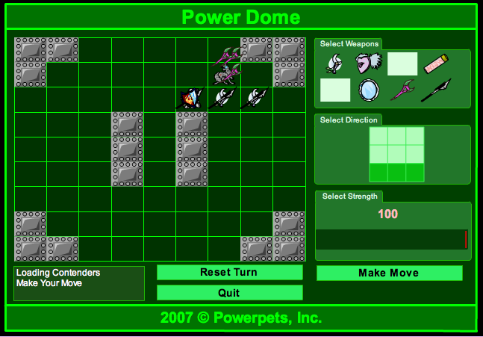
Action shot! Nailed him! Even though he blocked, he’s all out of strength, so my weapons just tore through him. The rest of the fight goes pretty much like this until he’s dead. Slowly chip away at his armor until he’s down using 20-50 strength each turn. After a few moves, I’m facing Randy in this position:
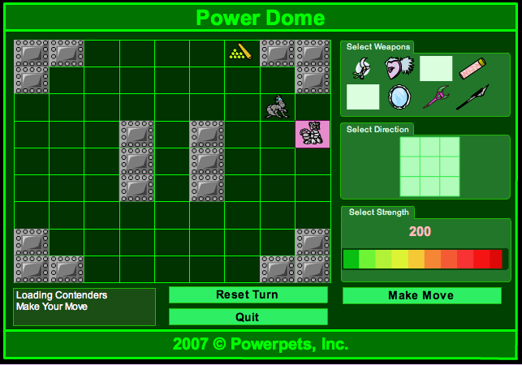
Notice that Randy now is against the wall and I’m northwest of him. This is perfect for us. Now, this next move is optional, and if you like slowly chipping away at Randy’s armor with dual short range weapons and shadowing him, continue to do that, but for those of you who want to do some serious damage with a guaranteed hit, this is your chance. Because Randy has his back to a wall, we are guaranteed a hit if we move correctly. Remember that Radioactive Claw we equipped? This is your chance to wreak some havoc. Notice if we move southwest and use one short and one medium ranged weapon, RAGARDLESS of where Randy moves, he’ll take damage from one of our weapons. Knowing he has 0 strength, even if he hits us with dual medium ranged weapons, we won’t take much damage. So, this is our chance to do some serious damage. I’m going to move southwest, use my Radioactive Claw and Moon Hook Blade at 200 strength. I don’t usually advocate using 200 strength, but we’re guaranteed a hit here, so it’s worth it. Before we move, this is what it looks like:
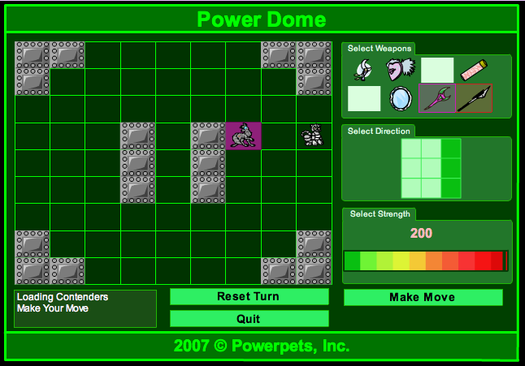
I’ve picked my square for next turn. Notice where I’m aiming and how much strength I’m using. Also, note that I’m using medium AND short ranged weapons. Randy has nowhere to hide from this attack. If he moves north or south he’ll take damage from my medium ranged weapon, and if he moves northwest, west or southwest, he’ll take damage from my short ranged weapon. I’m using my Baru Blade here because Randy is lowest in leather and titanium armor at this point. I want to get one of those to 0 as soon as possible to force Randy to repair. Once he repairs, he won’t have anymore tricks and it’s an easy win.
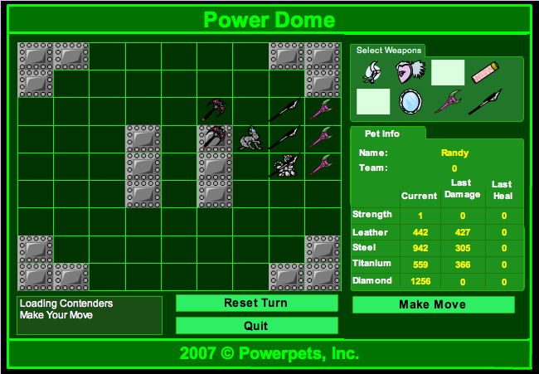
Notice how Randy moved in to close range, but he still took a ton of damage from my Baru Blade. Next turn he’ll probably use his repair patch, and then I’ll be able to just chip away at him and if he gets pinned against anymore walls, I’ll use the same strategy shown here to ensure I get a big hit in. Because I’m not sure where he’ll move next, I’ll go back to shadowing him. I move southeast to where he’s standing and start using short ranged weapons at 20-50 strength and chip away at his armor until he’s all out of armor, or until I get another chance like the turn I just took to really do some damage.
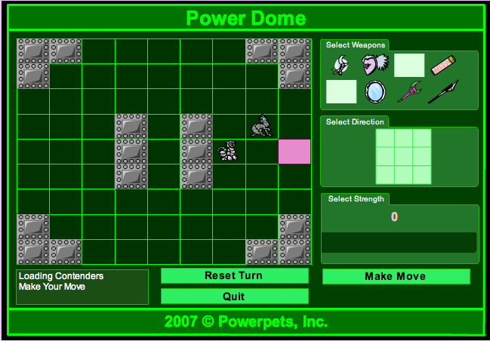
Again, Randy ends up against a wall. Like last time, I’ll move to the magenta square, across from Randy, and use a medium and short ranged weapon at 200 strength. He has nowhere to go, so he’ll be taking damage from one of my weapons.
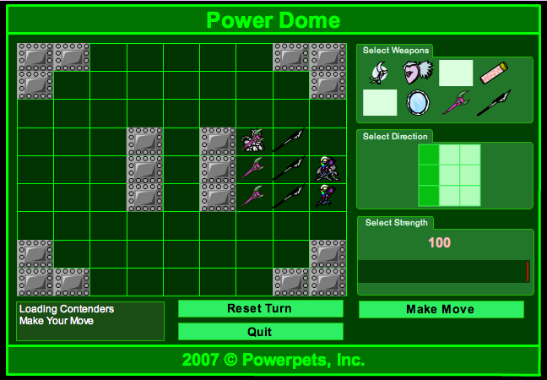
He stayed at medium range and took a ton of damage! He also hit me with both of his strong medium ranged weapons, but unfortunately for him, he’s all out of strength and they do minimal damage to me. At this point, I’ll need to use my last slime vial to ensure I have plenty of strength, and try to get back in range to shadow him until I get another chance to hit him hard. Once I’m back within short range, I resume shadowing him and using dual short range with 20-50 strength, slowly chipping away at his armor.
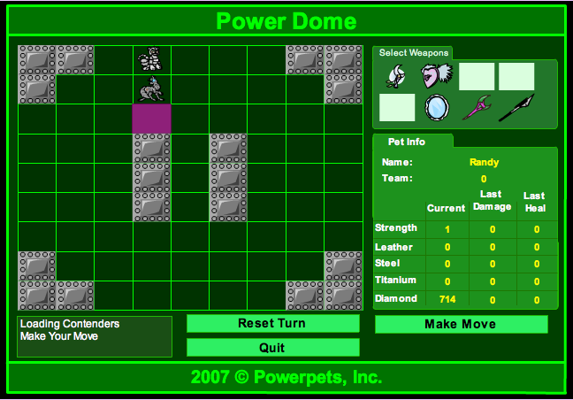
Again, Randy has gotten himself up against the wall. This time he is down to only 714 diamond left, and he’s already used his Multi Repair Patch 1000. I’m going to move south, use my Radioactive Claw and Moon Hook Blade (Baru Blade is weak vs. diamond) at 200 strength and aim north to ensure a hit. Even if Randy survives this attack, he’ll be extremely low, and then my shadowing coupled with chipping away at his armor with dual short ranged weapons will finish the job in a few turns.
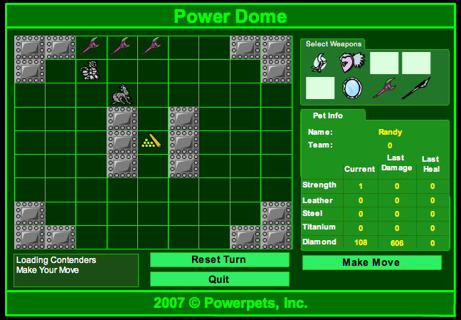
Randy decides to move southwest, where he is hit with my Moon Hook Blade for 606 diamond damage! Because he’s back within short range, I resume shadowing him and using my dual short ranged weapons with 20-50 strength until he’s beaten.
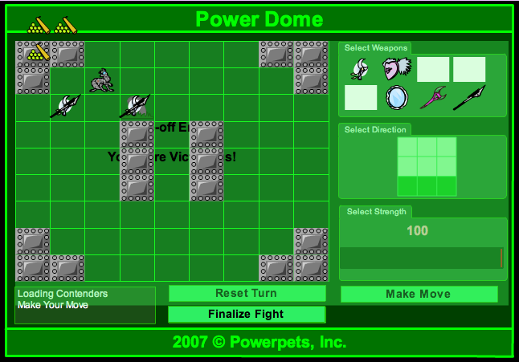
Randy decides to trade places with me. Unlucky for him though, because I aimed in that same spot with both of my short ranged weapons at 25 strength. Even with such little amounts of strength, I do more than enough damage because I’m dual-wielding and Randy’s other armor types are at 0, so the remaining armor type (diamond) takes more damage. Voila! You have just seen me defeat Randy with a Cupids Shield, Blizzard Shield, Baru Blade, Moon Hook Blade, Radioactive Claw, 2 Slime Powder Vial 1000mm, and a Multi Repair Patch 1000. These items are extremely cheap, and even they can beat Randy!

Phase 5 – Gloating

You are now free to roam the library without fear. No longer will Randy tell you to be quiet! No longer can the esteemed scholar challenge YOU! You’re now free to gloat to any non-human thing on the site! I hope you enjoyed your 5 minutes of fame ☺

Sum, sum, sum it up!

Glam finished the fight with about 900 strength left. I used a bunch of strength, but I was also pretty unlucky plenty of times (remember when Randy and I kept moving to the same square?). The screenshots you saw were all from the same fight. I faced Randy once with the items you just saw. This is an honest guide to show you how to beat Randy. The pictures have not been edited in anyway to fool you. I used those exact weapons, cross my heart!

Things to Remember:

- Stay close!
  - Remember, Randy doesn’t have short ranged weapons. Stay on top of him (shadowing). Get that wallet!
- Be conservative!
  - Don’t waste your strength when you don’t need to.
  - When you get caught in medium range, or get stuck with the possibility of being caught in medium range, don’t be afraid to block with 2 shields at 200 strength.
- Save your vials!
  - If you can’t get within short range of Randy without taking big hits, and you’re about to be beaten, feel free to take the loss and try again. Vials and repair patches are expensive. Don’t use them unless you’re giving it an honest try. It’s free to start over!
- Weapons
  - If your pet is low on overall strength (800-1200), I would suggest replacing the Radioactive Claw with a third slime vial to ensure you have enough strength to finish the fight. Don’t worry about not being able to use the 200 strength medium/short range combo. Shadowing him is still very effective, and you’ll have 1000 more strength to use towards that goal.
  - I also don’t use a long ranged weapon. I don’t use a long ranged weapon because I find it pretty useless against Randy. Because the medium ranged weapon is even optional, using a long ranged weapon just doesn’t make sense to me. I think a slime vial or a multi repair patch is much more important.
- Chin up! Chest out!
  - Randy is a tough PEST to beat, after all, he awards a stone.
  - Don’t get discouraged if you don’t beat him the first time. Try, try again.
  - If you mess up the beginning of the fight, start over! Luckily this isn’t real life; it DOES have a reset button ☺
Afterword:

I hope you’ve enjoyed my guide. Hopefully you’ll have a shiny new Emerald Stone on your profile soon to remind you of your struggles. If there’s any question I can answer, feel free to drop me a pmail. I’ll do my best to respond as soon as possible. Good luck fighting Randy! And remember: Chin up! Chest out!

